Please submit your application by mail or fax to:
Karaku:
Mail: 312 Tatebehiyoshi-cho, Higashiomi
Fax: 0748-36-2113

2021 Training for New Foreign Caregivers Application Form
Application Date Year: Month: Day:
Name |  | Date of Birth |  |  | Nationality
Residency Status |  |  | How long have you been in Japan?  years months
Address 〒 |  |  |  | Telephone Number
Fax | Email
Can you speak Japanese? Can you read and write Japanese?
1. I can have at least everyday conversations. 1. Yes, hiragana, katakana and at least some kanji
2. I can have basic conversations. 2. Yes, some hiragana
3. I can barely speak Japanese. 3. No
Preferred date of interview (please mark the date with a circle)
（ ）Saturday, October 16, 9:30-12:30・（ ） Sunday, October 17, 9:30-12:30
- There will be a simple Japanese proficiency test during the interview.
Application form QR code

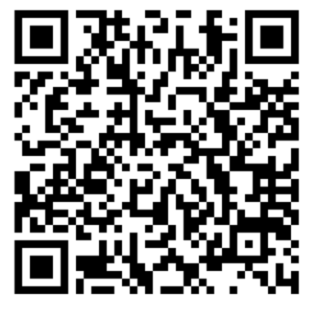
- We may contact you directly by telephone or by email.
- To stop the spread of COVID-19, there may be changes in the staff or schedule. In the event that the course is not completed within a year and a half of the start, it will become invalid.
The information on this form will only be used for the Training for New Foreign Caregivers.

Tentative Training Calendar
Sat., November 6  9:00 AM-5:00 PM | Sun., November 7  9:30 AM-4:30 PM | Sat., November 13  9:30 AM-4:30 PM | Sat., November 20  9:30 AM-4:30 PM | Sun., November 21  9:30 AM-4:30 PM | Sat., November 27  9:30 AM-4:30 PM
Sat., December 4  9:30 AM-4:30 PM | Sun., December 5  9:30 AM-4:30 PM | Sat., December 11  9:30 AM-12:30 PM | Sat., December 18  9:30 AM-4:30 PM | Sun., December 19  9:30 AM-4:30 PM | Sat., January 8  9:30 AM-5:00 PM
Sun., January 9  9:30 AM-4:30 PM | Sat., January 15  9:30 AM-4:30 PM | Sat., January 22  9:30 AM-5:00 PM | Sun., January 23  9:30 AM-4:30 PM | Sat., January 29  9:30 AM-5:00 PM | Sat., February 5  9:30 AM-5:00 PM
February 6 to 20  2-day hands-on training  10 AM-4 PM | Sat., February 26  9:30 AM-4:30 PM | Sun., February 27  9:30 AM-4:30 PM | Sat., March 5  9:30 AM-3:30 PM | Sat., March 12  Exam  9:30 AM-10:30 AM | Sat., March 19  Completion ceremony  10 AM- Noon

